Robot Framework- Appium

1. Emulator: Virtual Device, mirror image of your real device-> Android
2. Simulator: Mock device, simulates any version of s/w, can be configured as we need, can create our own configurations. Ex: IOS, iphone, ipad
3. Real device: holding in device

Appium server (Hub)- runs the code and selects the device

IDE

Robot Framework- write code

No device

No device

No device

Appium fetches the code from IDE and selects the device from the No device where the application is present and runs the code on that device.

Automation tools

1. UI Automator – Android
2. Xcode – Ios

3 categories of Applications

1. Native: Anything which is inbuilt or anything which is not going to web.
2. Hybrid: Any app which is combination of Web + Native, i.e. installed on phone but for the some purpose that takes you to Web is called hybrid app.
3. Web:

BrowserStack

1. Create a device
2. Runs code in multiple devices.

Android studio: Can Create own device

**In Android Studio**

New create project-> Empty activity

Tools-SDKmanager->copy path (C:\Users\Hp\AppData\Local\Android\Sdk)

Tools-> Device manager-> delete the existing one if present -> Create new-> select the phone u want to use-> select the OS-> Finish

Select the version u installed->Next-> give the name(AVD name) -> Finish

Run -> to check the device

Save a bat file in ur machine and run-> the device will run without android studio

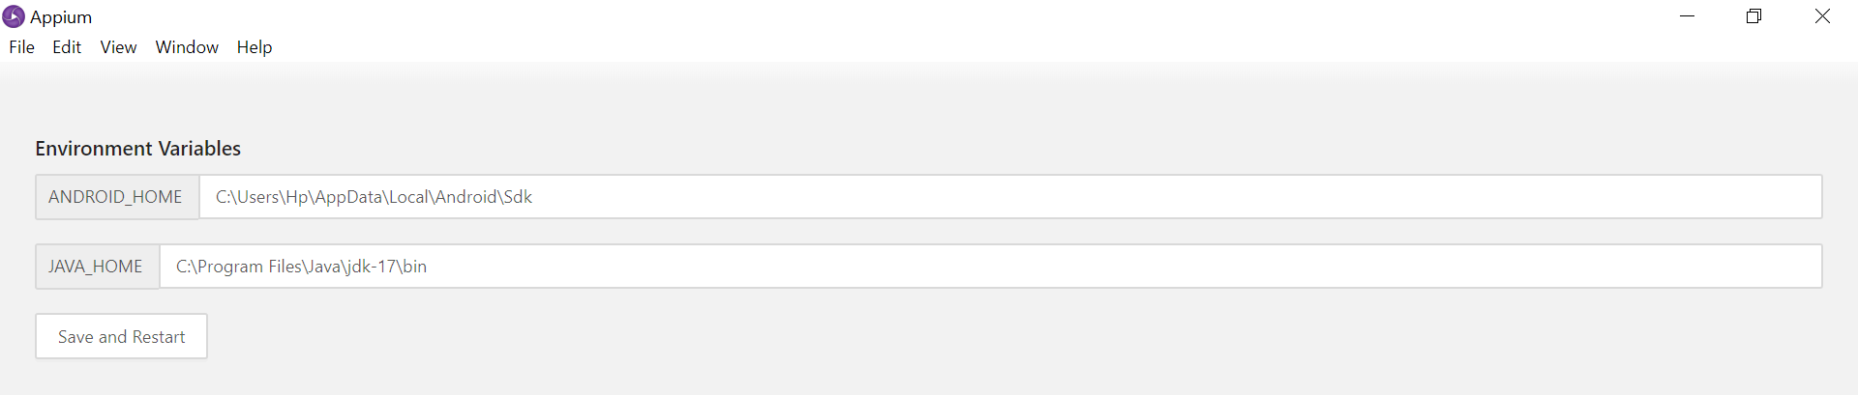

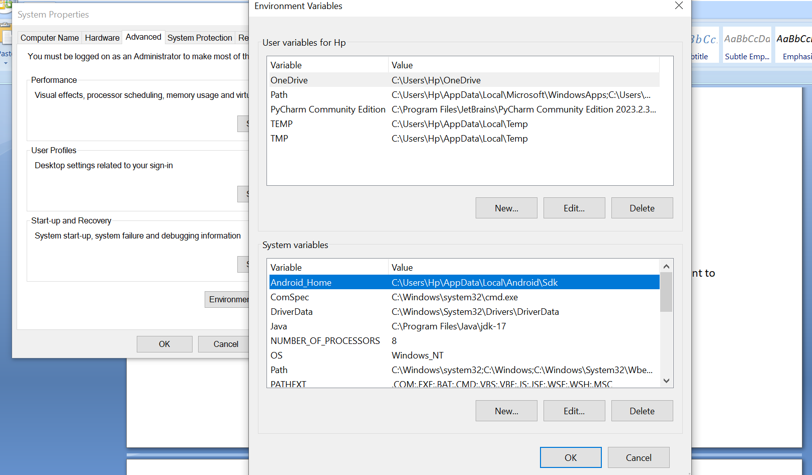

PATH variables

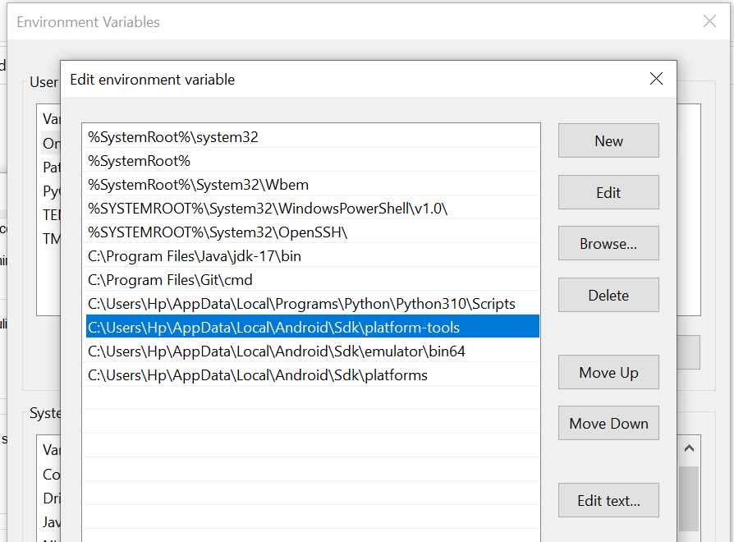

UIautomator – is used to inspect elements

**Commands in cmd (from sdk)**

adb devices -> to bridge the devices

adb start-server-> to start the server

adb kill-server -> to kill adb logs

**Capabilities:**

Device name – Adb name(Lokitha)

Platform Name- Android

App package & App activity – this will find the device and run the application

1. **Calculator capabilities to be added in Appium**

**Package name:** com.android.calculator2

**Activity name Activities:** com.android.calculator2.Calculator

1. **General stores**

com.androidsample.generalstore

com.androidsample.generalstore.SplashActivity

**Device capabilities to be added in Appium**

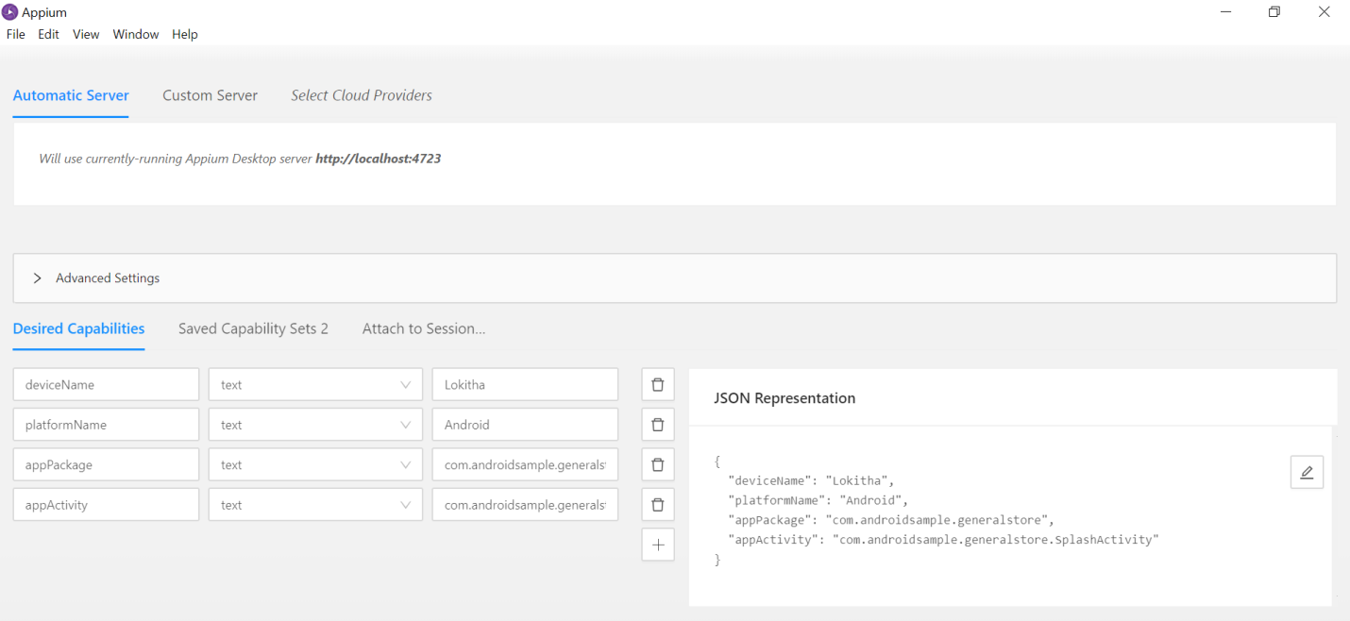

**for mobile there will be 2 id’s -> accessibility id and resource id**

the id first shown is accessibility Id

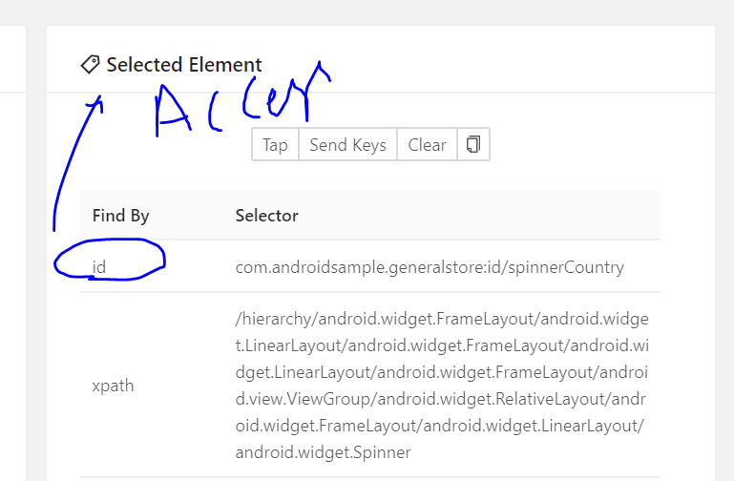

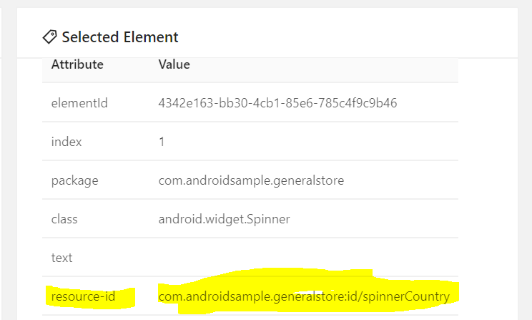

#name,class, xpath, css, id(accessbility and resourceid) to identify the element in Mobile